

***Rockets Basketball Camp Easter 2018***

Rockets Basketball Club is a year-round voluntary organisation with the aim of developing young kids into brilliant basketball players. Whether you are a Beginner or an Elite Level player we have the program to suit you. The combination of our young, enthusiastic, coaching staff and modern coaching methods ensure your child will develop to their best ability while enjoying a fun and enjoyable atmosphere. Our camp focuses on all aspects of the game to offer players every tool needed to improve their individual game and team skills.

All of our coaches are fully vetted and approved by the relevant associations so parents can feel safe that we’re the best in the business and supply a safe learning environment for children.

Places will fill fast and are on a strictly first come basis. We want to keep the numbers small to ensure each player receives the most from this experience.

**Players Will Need:**

* An appropriate size ball (clearly labeled, if available)
* Water Drink
* Towel
* Open and ready to learn mind
* Positive Attitude

**Camp Format:**

Our camp philosophy is to provide each player with the tools to improve and develop their game. These fun skill sessions will focus on development and progression of current skills

Players will be divided into both age and ability levels. We will monitor groups through continued assessment to ensure all players are happy and have the chance to develop to their full potential.

***Booking Form***

Player Name: D.O.B. :

Address: ____________________________

____________________________

Club/School: _________________________

Medical Issues: _______________________

Parent Email: ________________________

Is your child covered with Brennan 24hr Schools Insurance? Yes  No 

**Emergency Contact**

Name: _______________________________________________

Telephone: __________________________

Level:

Intermediate: (2006-2010) 

Advanced: (2002-2005) 



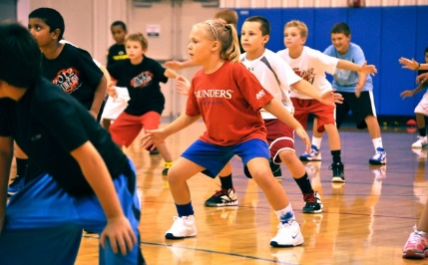

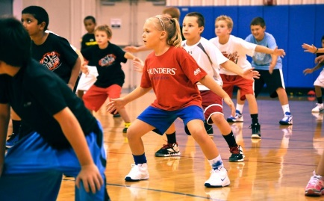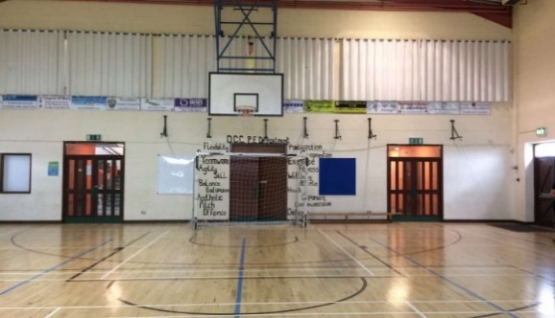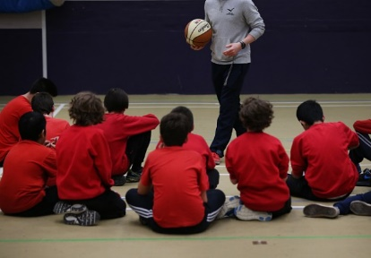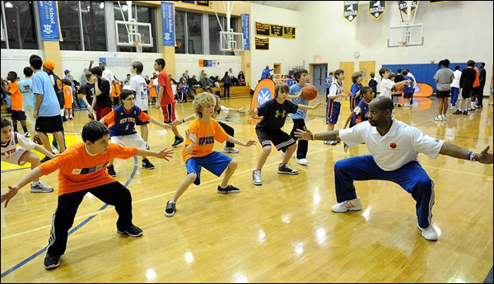

***Rockets Basketball Camp 2018***

Please send all application forms and payments to:

Brenda Meehan,

9, Manorlands,

Dunshaughlin,

Co. Meath

Phone: 086 893 5605

Email: [bmeehanbball@gmail.com](mailto:bmeehanbball@gmail.com)

Neither, camp directors, Rockets Basketball or camp staff are held responsible for any personal injury/lost or stolen items while attending camp.

I have read and agree to abide by all terms, conditions and rules while attending camp.

Parent/Guardian Signature:

Date:

/ /2018

Don’t delay book today!

Email bmeehanbball@gmail.com

***Rockets Basketball Easter Camp 2018***

**Venue:**

Dunshaughlin Community Centre

**Cost: €50pp**

**Category Dates:**

Intermediate: 26th – 29th March

Time: 9am – 1pm

Age/Year: 2006-2010

Advanced:26th – 29th March

Time: 2pm – 6pm

Age/Year: 2002-2005